**Working with Graph Database : Neo4j**

**Inserting data of students**

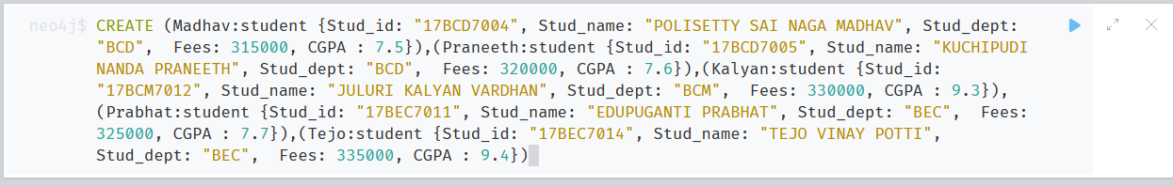

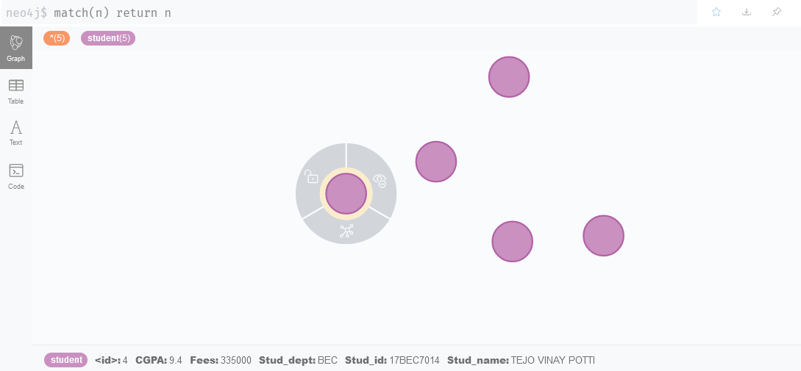

**Inserting data of department**



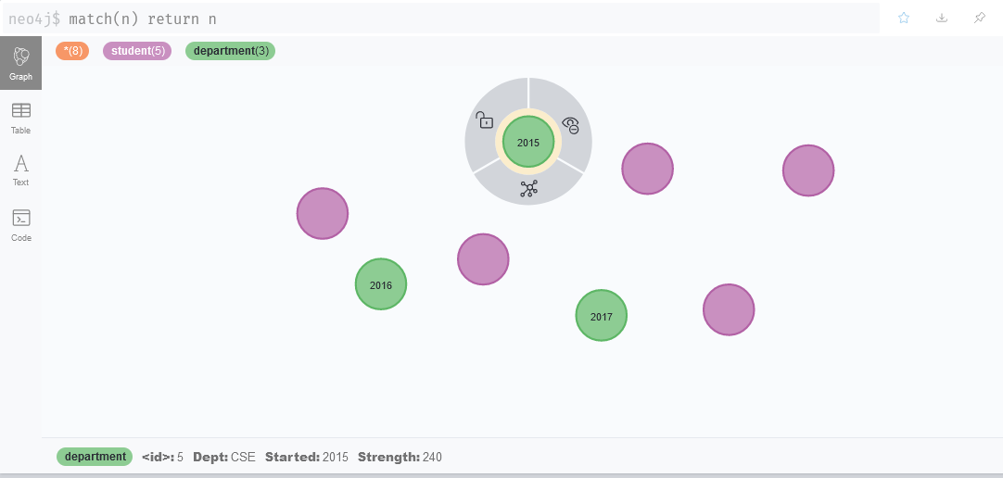

**Inserting data of course**



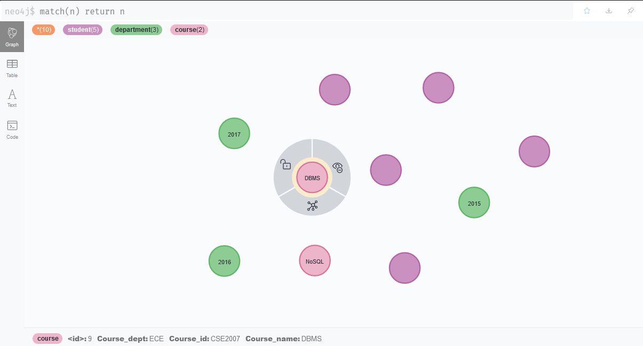

**Making relation of existing nodes Belongs_to**



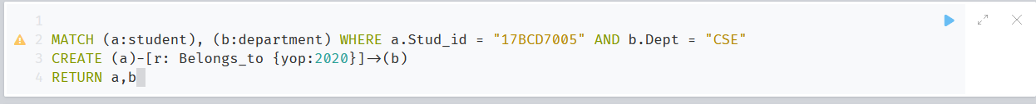







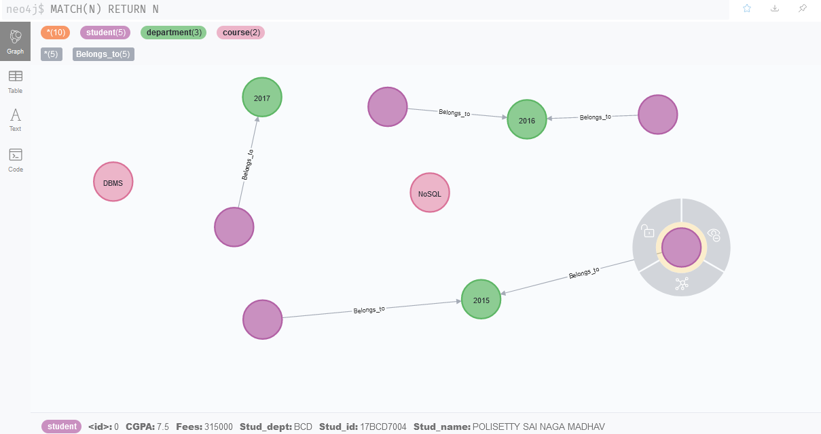

**Making relation of existing nodes studies**













**Final graph structure**

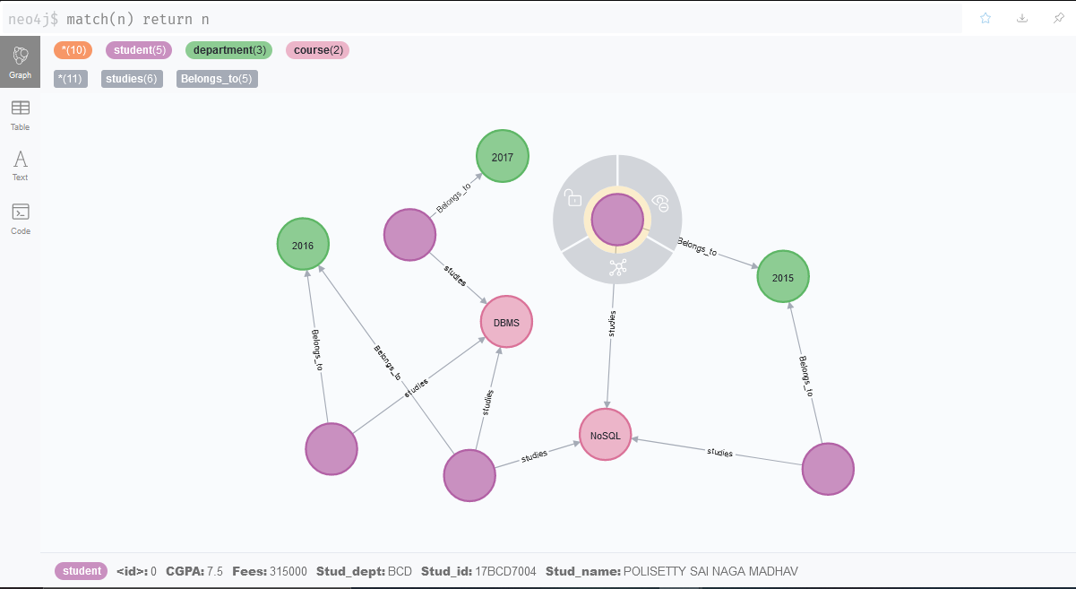

**Queries**

1. Display all student details.

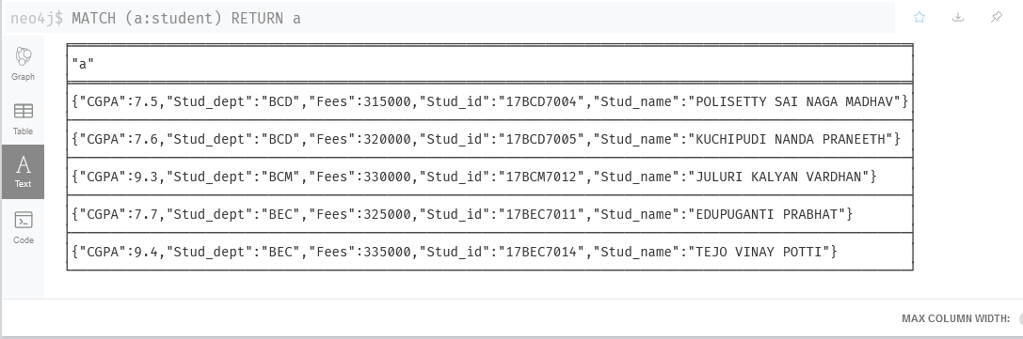

2. Display all students who belong to ECE department

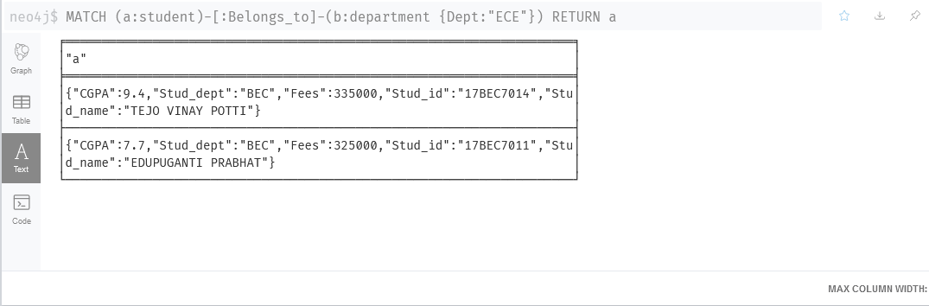

3. Display the all the department names

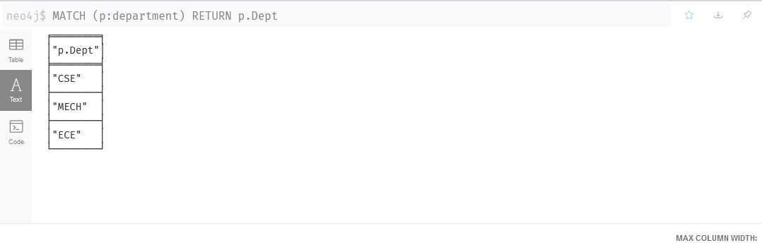

4. Display the student’s id who are all studying NoSQL course

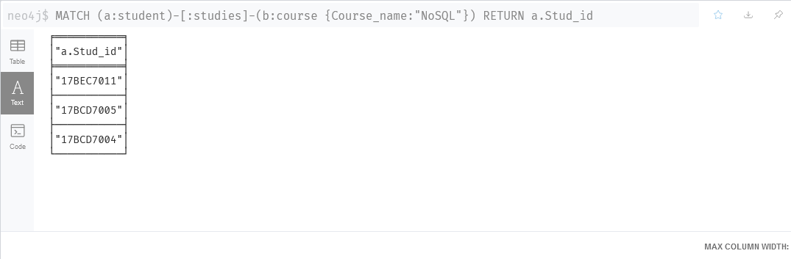

5. Find the courses of student id 17BEC7011

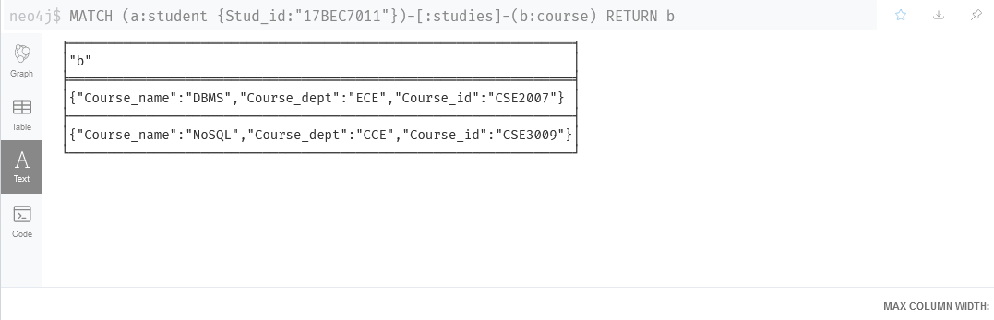

6. Update the fees 10% increment for the students of CSE department

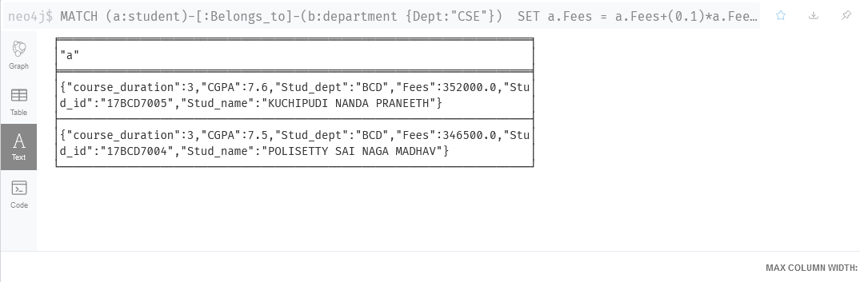

7. Add new property to all the course as “course_duration” and assign default

value as 3

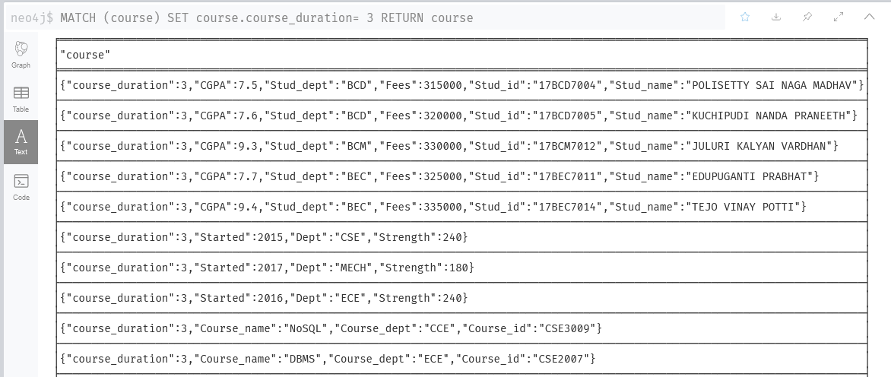

8. Display all the nodes names in the graph in ascending order

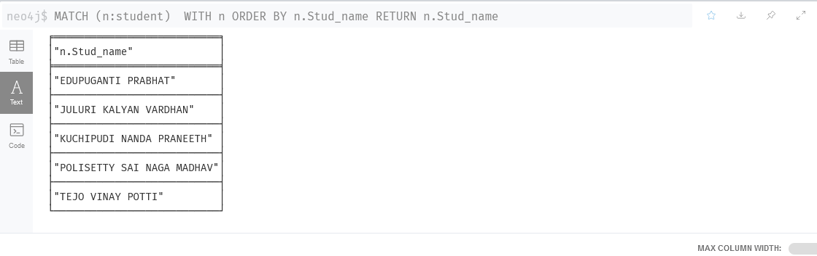

9. Display all the students of CSE and ECE

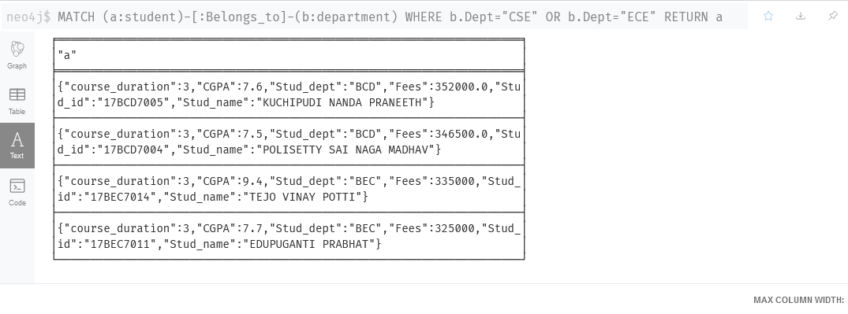

10.Display all the courses id and name.

